### 

### Semester Two Examination, 2021

### Question/Answer booklet

# MATHEMATICS METHODS

**UNIT 3 & 4**

## Section One:

## Calculator-free

|  |  |
| --- | --- |
| **Your Name:** |  |
| **Your Teacher’s Name:** |  |

## Time allowed for this section

Reading time before commencing work: five minutes

Working time: fifty minutes

## Materials required/recommended for this section

***To be provided by the supervisor***

This Question/Answer booklet

Formula sheet

***To be provided by the candidate***

Standard items: pens (blue/black preferred), pencils (including coloured), sharpener, correction fluid/tape, eraser, ruler, highlighters

Special items: nil

## Important note to candidates

No other items may be taken into the examination room. It is **your** responsibility to ensure that you do not have any unauthorised material. If you have any unauthorised material with you, hand it to the supervisor **before** reading any further.

|  |  |  |  |  |  |
| --- | --- | --- | --- | --- | --- |
| Question | Marks | Max | Question | Mark | Max |
| 1 |  | 7 | 4 |  | 8 |
| 2 |  | 9 | 5 |  | 12 |
| 3 |  | 7 | 6 |  | 7 |

**Structure of this paper**

|  |  |  |  |  |  |
| --- | --- | --- | --- | --- | --- |
| Section | Number of questions available | Number of questions to be answered | Working time (minutes) | Marks available | Percentage of examination |
| Section One:  Calculator-free | 6 | 6 | 50 | 50 | 33 |
| Section Two:  Calculator-assumed | 11 | 11 | 100 | 100 | 67 |
|  |  |  |  | **Total** | 100 |

**Instructions to candidates**

1. The rules for the conduct of the Western Australian Certificate of Education ATAR course examinations are detailed in the *Year 12 Information Handbook 2019*. Sitting this examination implies that you agree to abide by these rules.
2. Write your answers in this Question/Answer booklet.
3. You must be careful to confine your answers to the specific questions asked and to follow any instructions that are specific to a particular question.
4. Additional pages for the use of planning your answer to a question or continuing your answer to a question have been provided at the end of this Question/Answer booklet. If you use the space to continue an answer, indicate in the original answer space where the answer is continued, i.e. give the page number.
5. **Show all your working clearly.**Your working should be in sufficient detail to allow your answers to be checked readily and for marks to be awarded for reasoning. Incorrect answers given without supporting reasoning cannot be allocated any marks. For any question or part question worth more than two marks, valid working or justification is required to receive full marks. If you repeat any question, ensure that you cancel the answer you do not wish to have marked.
6. It is recommended that you **do not use pencil**, except in diagrams.
7. The Formula sheet is **not** to be handed in with your Question/Answer booklet.

**Section One: Calculator-free (50 Marks)**

This section has **six** questions. Answer **all** questions. Write your answers in the spaces provided.

Spare pages are included at the end of this booklet. They can be used for planning your responses and/or as additional space if required to continue an answer.

● Planning: If you use the spare pages for planning, indicate this clearly at the top of the page.

● Continuing an answer: If you need to use the space to continue an answer, indicate in the original answer space where the answer is continued, i.e. give the page number. Fill in the number of the question that you are continuing to answer at the top of the page.

Working time: 50 minutes.

**Question 1 (7 marks)**

A student gets at least 8 hours of sleep 40% of the nights; the sleeping schedule is independent from night to night. Let $X$ represent the number of nights where the student gets at least 8 hours of sleep during the next 4 nights.

1. Determine the probability distribution of $X$. (2 marks)
2. Determine $E\left(X\right)$ and $Var(X)$. (2 marks)
3. Determine the probability of the student getting **at least** one night of 8+ hours of sleep during the 4 nights. (3 marks)

**Question 2 (9 marks)**

1. $F(x)=\frac{1}{e^{f\left(x\right)}}$, $f(3) = 0$ and $f’\left(3\right)= -1$, determine the value for $F’\left(3\right).$ (3 marks)
2. Determine the gradient of the line tangent to the graph of $y=ln(\sqrt{3x+1})$ at $x=1$. (3 marks)

1. Given that $g\left(x\right)={\left(f\left(x\right)\right)}^{3}, f\left(0\right)=-\frac{1}{2}$ and $f^{'}\left(0\right)=\frac{8}{3}$, determine an equation of the line tangent to the graph of $g(x)$  at $x=0$ . (3 marks)

**Question 3 (7 marks)**

A projectile is launched upward from ground level with an initial velocity of $v_{0}=100m/s$ and acceleration $a=-20m/s^{2}.$

1. Determine the velocity at $t=4s$ and $t=6s.$ (2 marks)
2. Determine the maximum height the projectile will rise and the time when that occurs.

(3 marks)

1. Determine the **speed** of the projectile when it hits the ground. (2 marks)

**Question 4 (8 marks)**

The discrete random variable $X$ has a probability distribution as follows.

|  |  |  |  |  |
| --- | --- | --- | --- | --- |
| $$X$$ | $$1$$ | $$2$$ | $$3$$ | $$4$$ |
| $$P(X=x)$$ | $$a$$ | $$b$$ | $$0.3$$ | $$c$$ |

Where $a, b$ and $c$ are constants.

The cumulative distribution function $C(x)$ =  of $X$ is given in the following table.

|  |  |  |  |  |
| --- | --- | --- | --- | --- |
| $$X$$ | $$1$$ | $$2$$ | $$3$$ | $$4$$ |
|  | $$0.1$$ | $$0.5$$ | $$d$$ | $$1$$ |

Where $d$ is a constant.

1. Determine the values for $a, b, c$ and $d$. (4 marks)
2. Determine $E\left(X\right).$ (2 marks)
3. Determine $P(3X+2≥8)$ (2 marks)

**Question 5 (12 marks)**

1. $\frac{d}{dx} {\left(lnx\right)}^{2}$. (2 marks)

Consider the function $f\left(x\right)=\frac{ln\left(x\right)}{x}$, for $x>0.$

1. Determine the coordinate of the turning point of $f(x)$. (3 marks)
2. Determine the coordinate of the point(s) of inflection of $f\left(x\right)$. (3 marks)
3. Determine the value for $a,$ so that the area of the region enclosed by $f\left(x\right), x-axis$ and $x=a$ is exactly $\frac{1}{2}$. (4 marks)

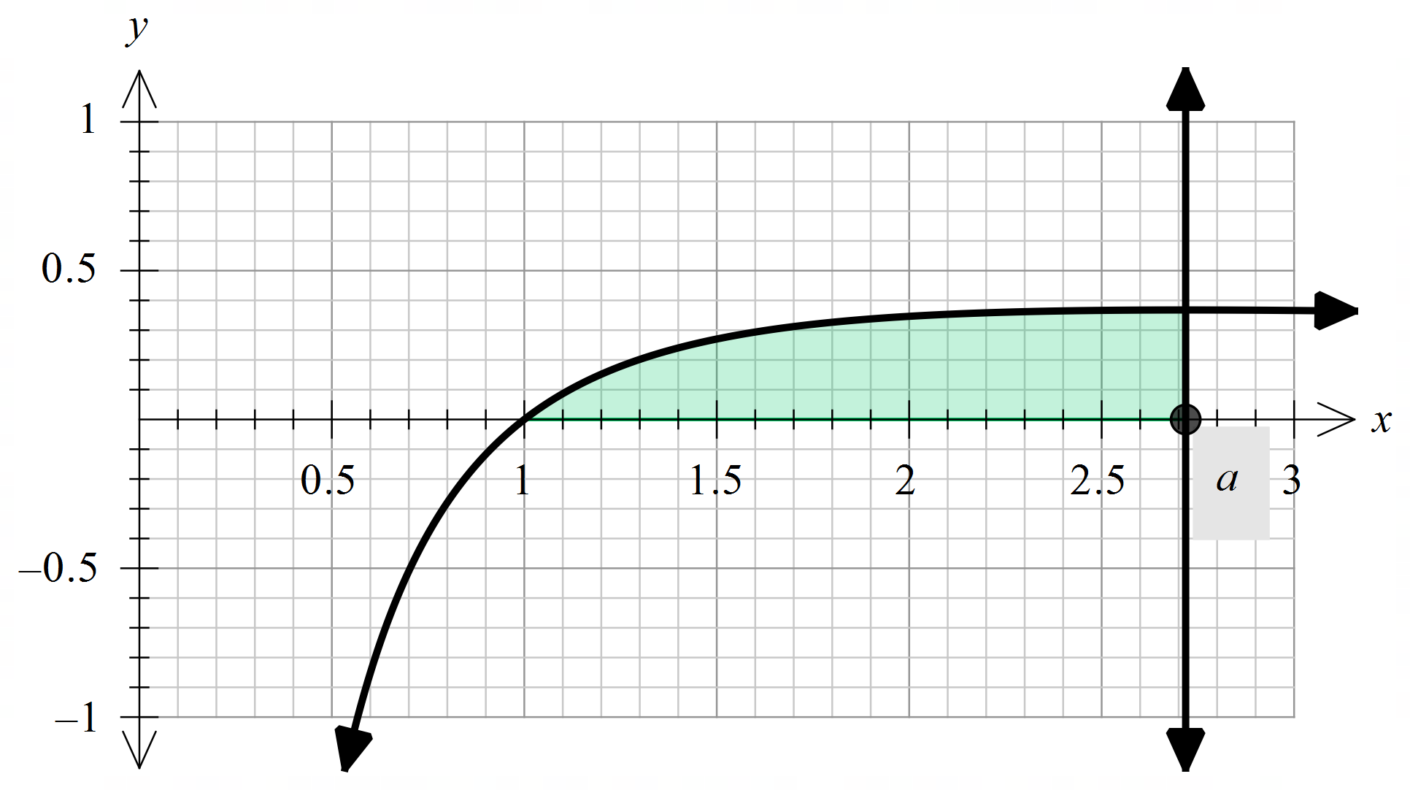

**Question 6 (7 marks)**

A trough for holding water is formed by taking a piece of sheet metal $60 cm$ wide and folding the $20 cm$ on either end up as shown below.

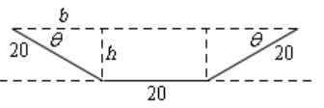

1. Determine the expression for the base $b$ and the height $h$ in terms of $θ$.

(2 marks)

1. Determine the angle $θ$ that will maximise the amount of water that the trough can hold.

Hint: $\sin^{2}{θ=1-\cos^{2}{θ}}$.

(5 marks)

Additional working space

Question number: ________

Additional working space

Question number: ________